//Hf113.sumulux.com

Yesterday we Tested Regular user pages on //Hf113.sumulux.com, here is our feedbacks:

1. Enter Communicator

Now: the whole page switched into the Communicator

Recommendation: pop-up Communicator float window within homepage.

1. Company Directory :no department set? Actually people like to group contacts in department.
2. About the regular user home page：
3. Can we use the top menu like Hipchat?

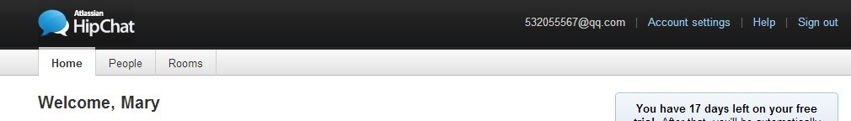

2) Two “Home” in the main page, need think over.

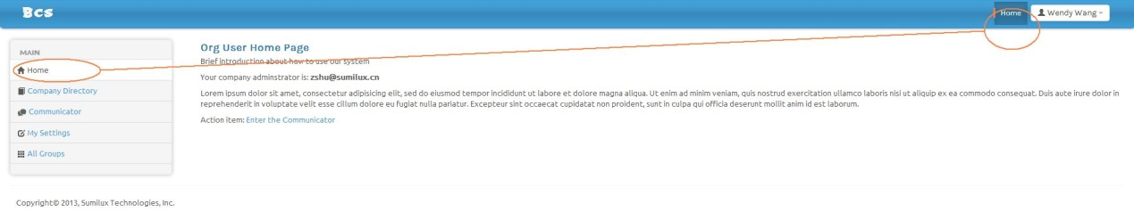

1. setting/account settings

no setting content now.

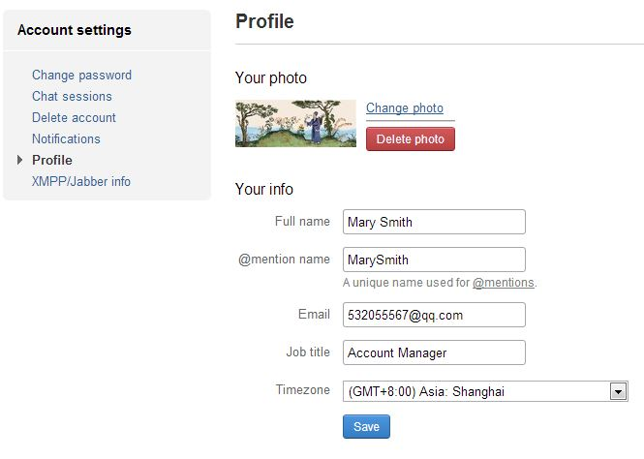

1. Violet：When chatting on the js client, it is recommended to display the members of the discussion group on the discussion group. For example, the members who are not online will display the offline status. When they go online, they can receive the chat content in the discussion group;
2. When chatting on the js client, you cannot wrap the text in the sending box;
3. As we have MS Lync 2010 deployed, we will try that today, and also test BCS.